**TABLE OF CONTENT**

**Chapter   
1.Introduction ………………………………………………………….……………………1** 1.1 Objective…………………………………………………………………………..1  
 1.2 Importance and Scope……………………………………………………………..1  
 1.3 Android Studio…………………………………………………………………….1  
 1.4 Android Architecture………………………………………………………………1  
 1.5 Methodology……………………………………………………………...……….2  
 1.6 Project Structure…………………………………………………………………...2 **2. System Requirement …………………………………………………….……………….4** 2.1 Introduction…………………..……………………………………………..……..4  
 2.2 Functional Requirement……………………………………………………..…….4  
2.3 Android Studio……….………………………………………………………...…4  
 2.4 Android Studio Emulator……………………………………………………....…5 **3. System Design……………………………………………………………………………...6** 3.1 Data Flow Diagram………………………………………………………………..6 **4. Implementation……………………………………………………………………….…..7** 4.1 Java………………………………………………………………………………..7  
 4.2 XML Implementation………………………….……… …………………………7  
 4.3 Java Implementation …………………………….…………………….………….8

**5. Test Case…………………………………………………………………………….…...13**

5.1 Test Cases Table….………………….……………………………………..……13 **6. Result……………………………………………………………………………………13** 6.1 Home Page ………………………………………………………………………13  
 6.2 Search Webpage …………………………………………………………………14  
 6.3 Converting Web Page into PDF ….……………………………………………15  
 6.4 Saving File To Device …………………………………………………..………16

6.5 Error Page (When Internet Connection Not Available)…………..………….….17

**7. Conclusion ………………………...…………………………………………………...18** 7.1 Conclusion….....…………………………………………………………………18

**LIST OF FIGURES**

**Fig. no Description Page No**

1.1 Project file in android view 3  
3.1 Dataflow diagram 6

**LIST OF SNAPSHOTS**

**Snapshot. no Description Page No**  
6.1 Home Page 14  
6.2 Search Webpage 15  
6.3 Converting Webpage into PDF 16  
6.4 Saving File To Device 17

6.5 Error Page 18

(When Internet Connection Not Available)

**Chapter 1**

**INTRODUCTION**

* 1. **Objective**

Sometimes there is a need to save some articles available on the internet in the form of PDF files. And to do so there are many ways, one can use any browser extension or any software or any website to do so. But in order to implement this feature in the android app, one can’t rely on other software or websites to do so. So to implement this amazing feature in the android app

* 1. **Importance and scope**

Sometimes there is a need to save some articles available on the internet in the form of PDF files. And to do so there are many ways, one can use any browser extension or any software or any website to do so. But in order to implement this feature in the android app, one can’t rely on other software or websites to do so. The app can help the user to save their Internet webview information in the pdf format.

* 1. **Android Studio**

Android Studio is an integrated development environment (IDE) for developing for the Android platform. It was announced on May 16, 2013 at the Google I/O conference. Android Studio is freely available under the Apache License 2.0.

Android Studio was in early access preview stage starting from version 0.1 in May 2013, then entered beta stage starting from version 0.8 which was released in June 2014. The first stable build was released in December 2014, starting from version 1.0. Based on JetBrains' IntelliJ IDEA software, Android Studio is designed specifically for Android development. It is available for download on Windows, Mac OS X and Linux, and replaced Eclipse Android Development Tools (ADT) as Google's primary IDE for native Android application development.

* 1. **Android Architecture**

We studied the Android system architecture. Android system is a Linux-based system, Use of the software stack architecture design patterns. The Android architecture consists of four layers: Linux kernel, Libraries and Android runtime, Application framework and Applications. Each layer of the lower encapsulation, while providing call interface to the upper.

* 1. **Methodology**

This project is made by using Android studio, Virtual emulator and Photoshop. The programming languages used for building the application are Java and XML .User interface is handled using XML codes. Backend programming is handled mainly through set of java codes.

The other libraries required are:

* Android SDK tools
* ARM EABI v7a System Image
* Intel x86 Atom_64 System Image
* Google APIs
* Google APIs ARM EABI v7a System Image
* GPU Debugging tools
* Intel x86 Emulator Accelerator (HAXM installer)
* Google USB drivers
* Google play services
* Android SDK platform tools
* Android SDK build tools
* SDK platform
* Android Support Library
* Google Web drivers
  1. **Project structure**

Each project in Android Studio contains one or more modules with source code files and resource files. Types of modules include:

* Android app modules
* Library modules
* Google App Engine modules

By default, Android Studio displays your project files in the Android project view. This view is organized by modules to provide quick access to your project's key source files. All the build files are visible at the top level under Grade Scripts and each app module contains the following folders:

* Manifests: Contains the AndroidManifest.xml file.
* Java: Contains the Java source code files, including JUnit test code.

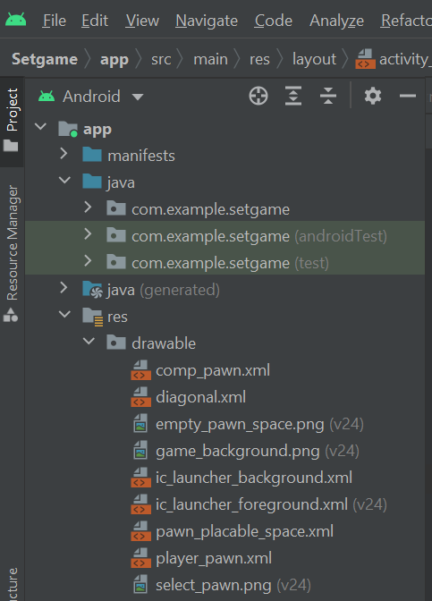

Fig 1.1: The project files in android view

**Chapter 2**

**SYSTEM REQUIREMENT**

**2.1 INTRODUCTION**

Requirements are during early stages of a system development as a specification of what should be implemented or as a constraint of some kind of on the system. They may be a user level facility description, a detailed specification of expected system behavior, a general system property, a specific constraint on the system, and information on how to carry out some computation or a constraint on the development of the system. The end product of the requirement analysis phase is a requirement specification. The requirement specification is a reconstruction of the result of this analysis phase.

Natural language is often used to write system requirements specifications. Further problems with natural language can arise when it is used for more detailed specification:

* Natural language understanding relies on the specification of the readers and writers using the same words for the same concept. This leads to misunderstandings because of the ambiguity of the natural language.
* A natural language requirements specification is over-flexible. You can say the same thing in completely different ways. It is up to the reader to find out when requirements are same and when they are distinct.

**2.2 Functional Requirement**

The functional requirements are the statement of services the system should provide, how system reacts to particular inputs and how system should behave in particular situation. It describes the functionality that the system provides. Our app requires:

* Username to provide a their name.

**2.3 Android Studio**

* 64-bit Microsoft Windows 8/10
* x86_64 CPU architecture; 2nd generation Intel Core or newer, or AMD CPU with support for a Windows Hypervisor
* 8 GB RAM or more
* 8 GB of available disk space minimum
* 1280 x 800 minimum screen resolution.

The process of building applications and games is resource-intensive, especially CPU. If your CPU is too old then your computer will be very hot and possibly overloaded. Therefore, we recommend using an Intel Core i5-8400 or a better CPU. In addition, the use of SSD also makes your work process much quicker and more comfortable than using a HDD.

**2.4 Android Studio Emulator**

Android Studio is the default development platform for Android application. It comes with collections of tools that help developers to make their apps and games specifically for Android devices. It also provides a built-in emulator which is used to test your app takes a few minutes to start.

Minimum system requirements

* Windows, Linux or Mac
* 64-bit distribution capable of running 32-bit applications
* 3 GB GAM • 2 GB hard disk space
* Minimum resolution needs to be 1280 x 800

**2.5 Java System requirement**

* Windows 10 (8u51 and above)
* Windows 8.x (Desktop) • Windows 7 SP1
* Windows Vista SP2
* Windows Server 2008 R2 SP1 (64-bit)
* Windows Server 2012 and 2012 R2 (64-bit)
* RAM: 128 MB
* Disk space: 124 MB for JRE; 2 MB for Java Update
* Processor: Minimum Pentium 2 266 MHz processor

**Chapter 3**

**SYSTEM DESIGN**

**3.1 Date flow diagram**

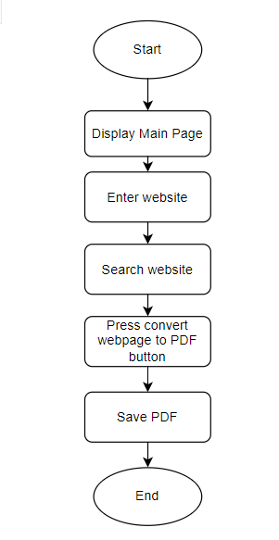

**Fig 3.1: Data flow diagram**

**Chapter 4**

**IMPLENTATION**

**4.1. Java**

There are several ways to create apps for Android devices, but their commended method for most developers is to write native apps using Java and the Android SDK. Java for Android apps is both similar and quite different from other types of Java applications. If you have experience with Java (or a similar language) then you’ll probably feel comfortable diving right into the code and learning how to use the Android SDK to make your app run. But if you’re new to programming or object- oriented languages then you’ll probably want to get familiar with the syntax of the Java language and how to accomplish basic programming tasks before learning how to use the Android SDK.

**4.2 XML Convert Web View To PDF Page Implementation**

<?**xml** version="1.0" encoding="utf-8"?>

<**RelativeLayout**

    xmlns:android="<http://schemas.android.com/apk/res/android>"

    xmlns:tools="<http://schemas.android.com/tools>"

    android:layout_width="match_parent"

    android:layout_height="match_parent"

    tools:context=".MainActivity">

  <!-- WebView to load webPage  -->

  <**WebView**

      android:id="@+id/webViewMain"

      android:layout_width="match_parent"

      android:layout_height="match_parent"/>

  <!-- Button To save the Pdf file when clicked -->

  <**Button**

      android:layout_alignParentBottom="true"

      android:textColor="#ffffff"

      android:background="@color/colorPrimary"

      android:text="Convert WebPage To PDF"

      android:id="@+id/savePdfBtn"

      android:layout_width="match_parent"

      android:layout_height="wrap_content"/>

</**RelativeLayout**>

android:textColor="#fff"

android:textSize="10sp"

android:textStyle="bold" />

</LinearLayout>

<EditText

android:id="@+id/etoutput"

android:layout_width="359dp"

android:layout_height="180dp"

android:layout_below="@+id/llout"

android:layout_marginTop="63dp"

android:alpha="0.8"

android:background="#ffffff"

android:gravity="start"

android:hint="output here"

android:padding="10sp"

android:textSize="20sp"

android:textStyle="bold" />

</RelativeLayout>

**4.3 Convert Web View To PDF Java Implementation**

**Main Activity.java**

import android.content.Context;

import android.os.Build;

import android.os.Bundle;

import android.print.PrintAttributes;

import android.print.PrintDocumentAdapter;

import android.print.PrintJob;

import android.print.PrintManager;

import android.view.View;

import android.webkit.WebView;

import android.webkit.WebViewClient;

import android.widget.Button;

import android.widget.Toast;

import androidx.annotation.RequiresApi;

import androidx.appcompat.app.AppCompatActivity;

public class MainActivity extends AppCompatActivity {

// creating object of WebView

WebView printWeb;

@Override

protected void onCreate(Bundle savedInstanceState) {

super.onCreate(savedInstanceState);

setContentView(R.layout.activity_main);

// Initializing the WebView

final WebView webView = (WebView) findViewById(R.id.webViewMain);

Initializing the Button

Button savePdfBtn = (Button) findViewById(R.id.savePdfBtn);

/ Setting we View Client

webView.setWebViewClient(new WebViewClient() {

@Override

public void onPageFinished(WebView view, String url) {

super.onPageFinished(view, url);

// initializing the printWeb Object

printWeb = webView;

}

});

// loading the URL

webView.loadUrl("https://www.google.com");

// setting clickListener for Save Pdf Button

savePdfBtn.setOnClickListener(new View.OnClickListener() {

@Override

public void onClick(View view) {

if (printWeb != null) {

if (Build.VERSION.SDK_INT >= Build.VERSION_CODES.LOLLIPOP) {

// Calling createWebPrintJob()

PrintTheWebPage(printWeb);

} else {

// Showing Toast message to user

Toast.makeText(MainActivity.this, "Not available for device below Android LOLLIPOP", Toast.LENGTH_SHORT).show();

}

} else {

// Showing Toast message to user

Toast.makeText(MainActivity.this, "WebPage not fully loaded", Toast.LENGTH_SHORT).show();

}

}

});

}

// object of print job

PrintJob printJob;

// a boolean to check the status of printing

boolean printBtnPressed = false;

@RequiresApi(api = Build.VERSION_CODES.LOLLIPOP)

private void PrintTheWebPage(WebView webView) {

// set printBtnPressed true

printBtnPressed = true;

// Creating PrintManager instance

PrintManager printManager = (PrintManager) this

.getSystemService(Context.PRINT_SERVICE);

// setting the name of job

String jobName = getString(R.string.app_name) + " webpage" + webView.getUrl();

// Creating PrintDocumentAdapter instance

PrintDocumentAdapter printAdapter = webView.createPrintDocumentAdapter(jobName);

// Create a print job with name and adapter instance

assert printManager != null;

printJob = printManager.print(jobName, printAdapter,

new PrintAttributes.Builder().build());

}

@Override

protected void onResume() {

super.onResume();

if (printJob != null && printBtnPressed) {

if (printJob.isCompleted()) {

// Showing Toast Message

Toast.makeText(this, "Completed", Toast.LENGTH_SHORT).show();

} else if (printJob.isStarted()) {

// Showing Toast Message

Toast.makeText(this, "isStarted", Toast.LENGTH_SHORT).show();

} else if (printJob.isBlocked()) {

// Showing Toast Message

Toast.makeText(this, "isBlocked", Toast.LENGTH_SHORT).show();

} else if (printJob.isCancelled()) {

// Showing Toast Message

Toast.makeText(this, "isCancelled", Toast.LENGTH_SHORT).show();

} else if (printJob.isFailed()) {

// Showing Toast Message

Toast.makeText(this, "isFailed", Toast.LENGTH_SHORT).show();

} else if (printJob.isQueued()) {

// Showing Toast Message

Toast.makeText(this, "isQueued", Toast.LENGTH_SHORT).show();

}

// set printBtnPressed false

printBtnPressed = false;

}

}

}

**Chapter 5**

**TEST CASES**

**5.1 Test Cases Table**

|  |  |  |  |  |  |  |  |
| --- | --- | --- | --- | --- | --- | --- | --- |
| Test Case Id | Test Scenario | Test Case | Test Data | Expected Result | Post Condition | Actual Result | Status (Pass/Fail) |
| TC_1 | Entering the URL | Search for website | URL | Should open the website specified by URL | Destination website | As expected | Pass |
| TC_2 | Clicking Convert button | Click on convert website to PDF button | User click | Should open print page | Renders print activity view | As expected | Pass |
| TC_3 | On clicking save button | PDF | User click | Should open file manager in device | Renders file manager | As expected | Pass |

**Chapter 6**

**RESULTS**

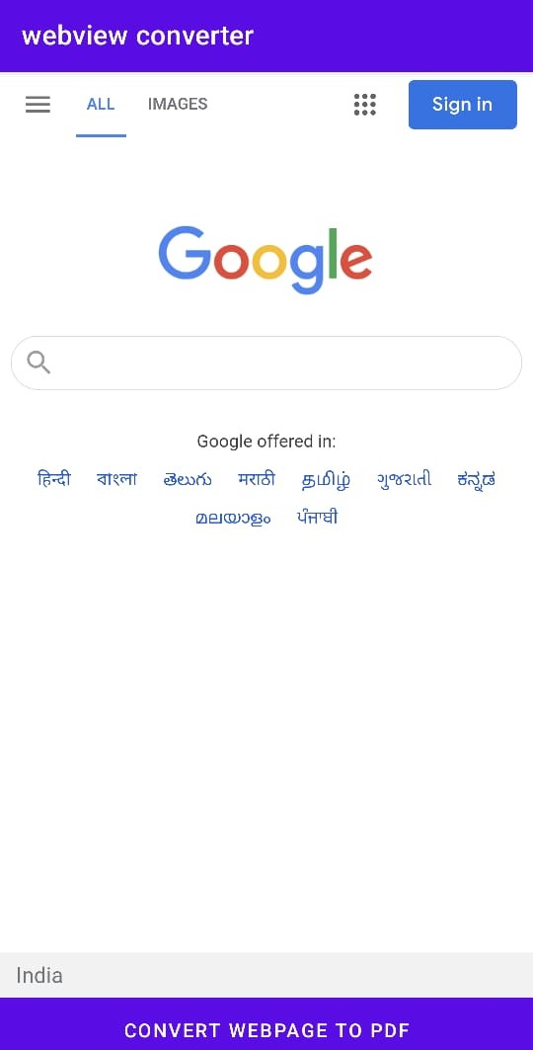

Fig 6.1: Home Page

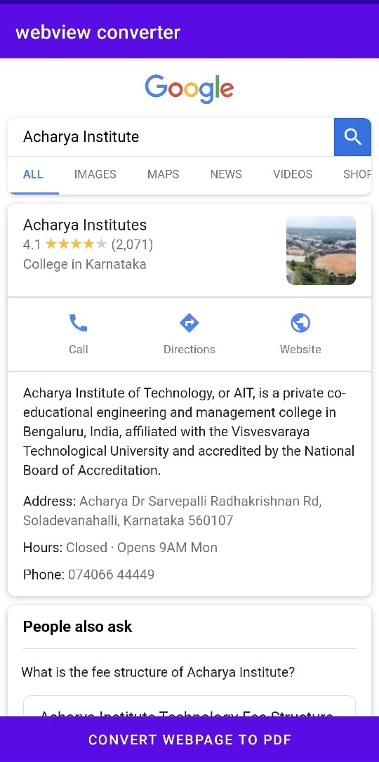

Fig 6.2:Search Webpage

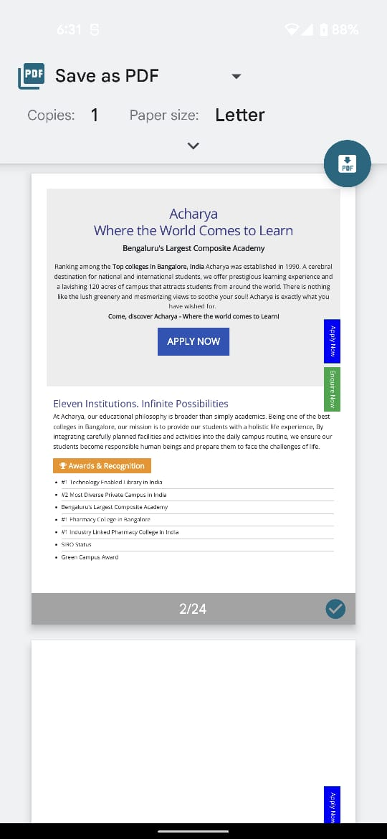

Fig 6.3:Converting Webpage into PDF

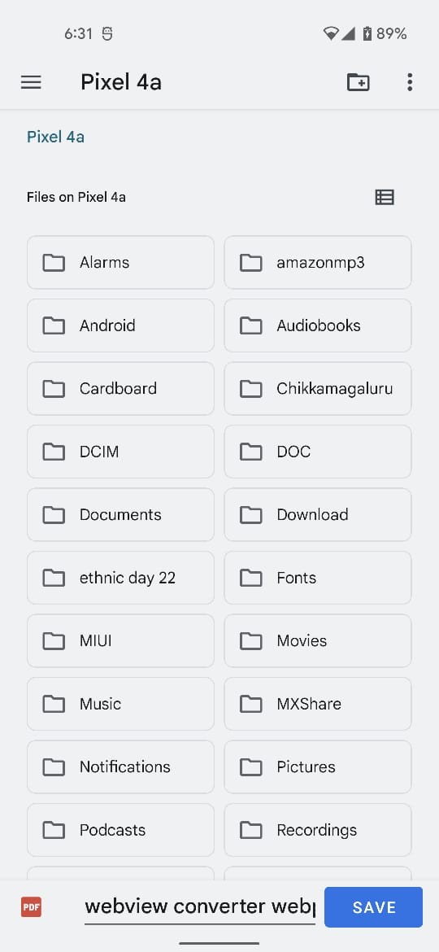

Fig 6.4:Saving File To Device

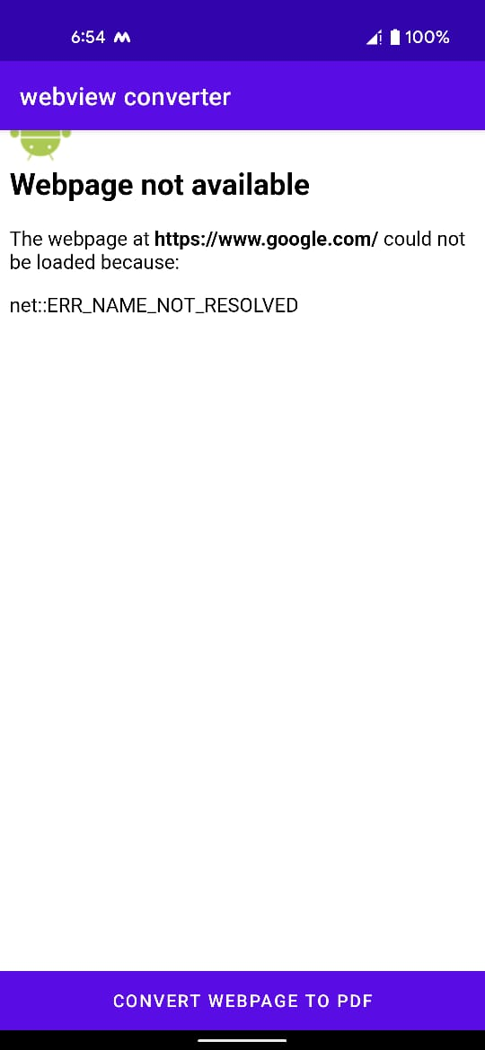

Fig 6.5: Error Page (When Internet Connection Not Available)

**Chapter 7**

**CONCLUSION**

**7.1 Conclusion**

Web view converter to PDF is a app that helps students in saving the web view into PDF. The app is a self dependent activity that can engage user in saving PDF, development of visualizing ideas. Android as a full, open and free mobile device platform, with its powerful function and good user experience rapidly developed into the most popular mobile operating system. This report gives an overview of the different challenges and issues faced in android app development. The experience of developing an android app is quite challenging, motivating as well as satisfying.